Project 7 Coin Detection with OpenCV
Name: Pawan Jayakumar Period: 2 Date: 2/27/20
Did you use OpenCV to detect coins? yes
What functions/methods from OpenCV did you use?

GaussianBlur()
Canny()
HoughCircles()
putText()
circle()
__________________________________________________________________________________
What functions/methods from OpenCV did you experiment with but ended not using?
Blur() replaced by GaussianBlur()
Experimented with slider bars and countour detections. There was a function for creating bounding circles for closed contours

Below do the following:
- Paste here 2 clear pictures of the initial picture, the picture with the original image and the circles you detected drawn in red (bolded and you may use more colors if you wish).
- Paste the content of your results.txt file

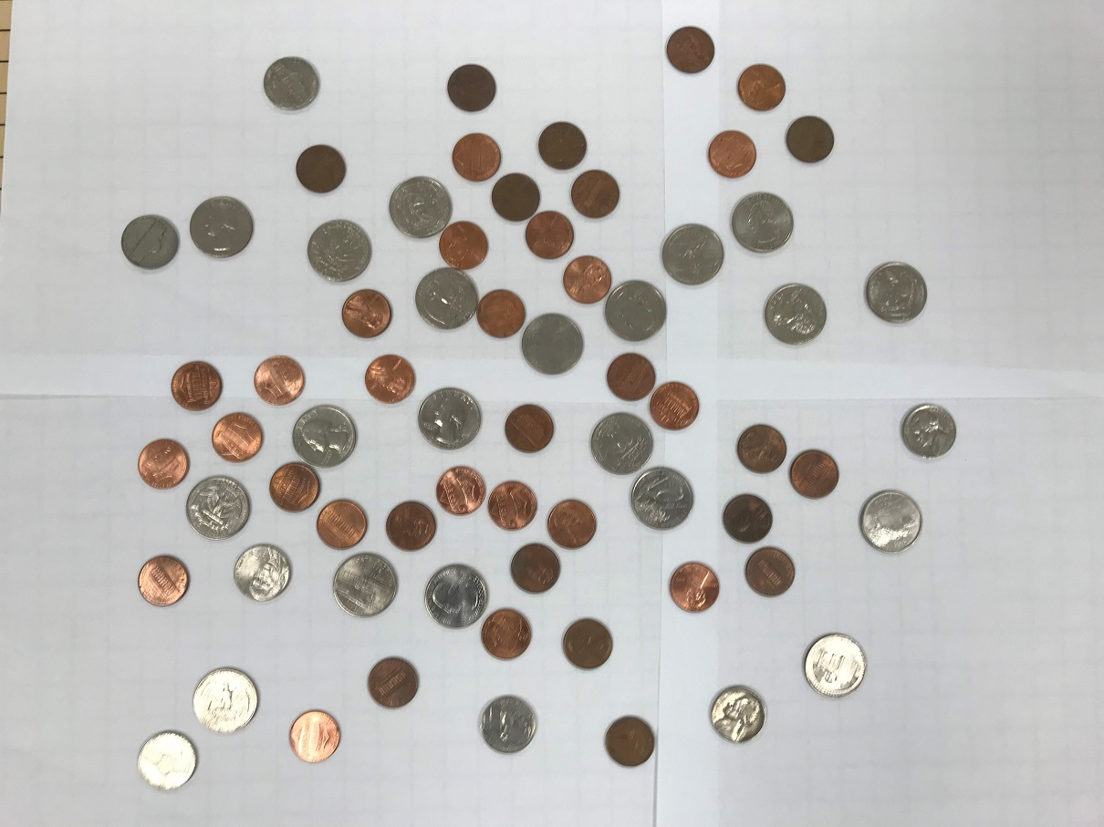
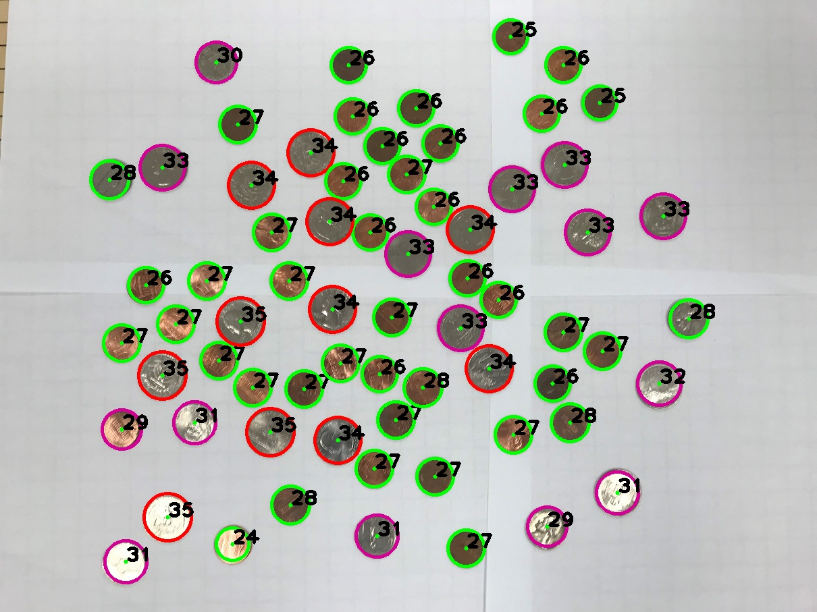

num pennies: 39 num quarters: 18 num nickels: 8 num dimes: 0 num half dollars: 0 total value: 529 cents

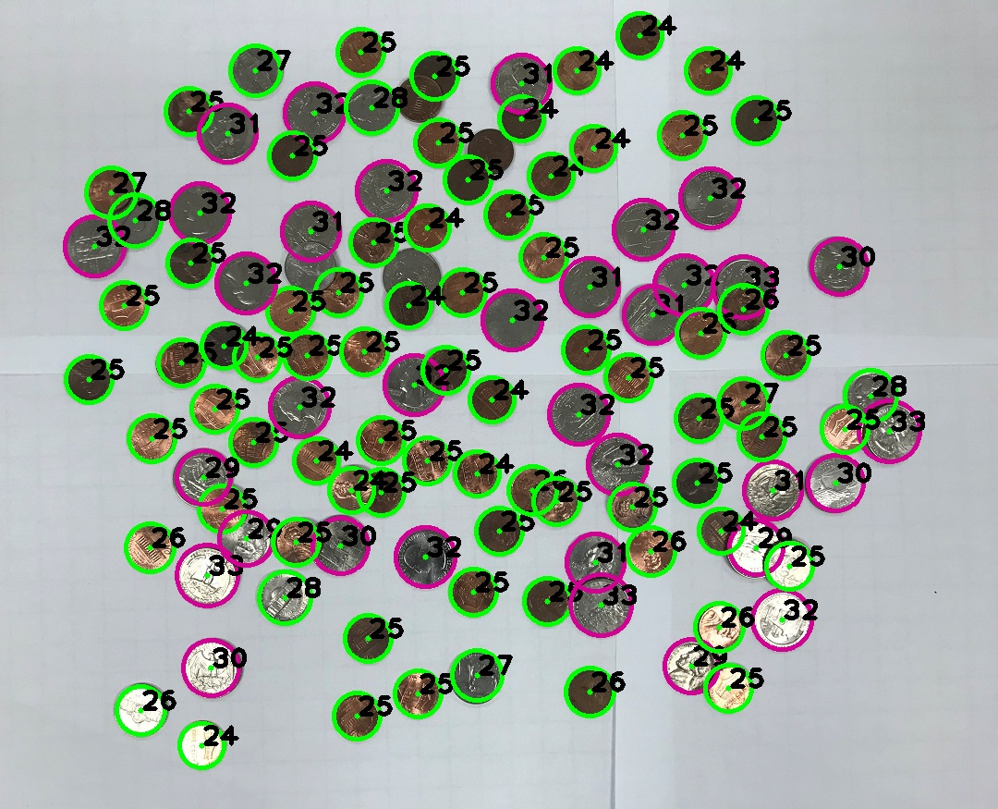

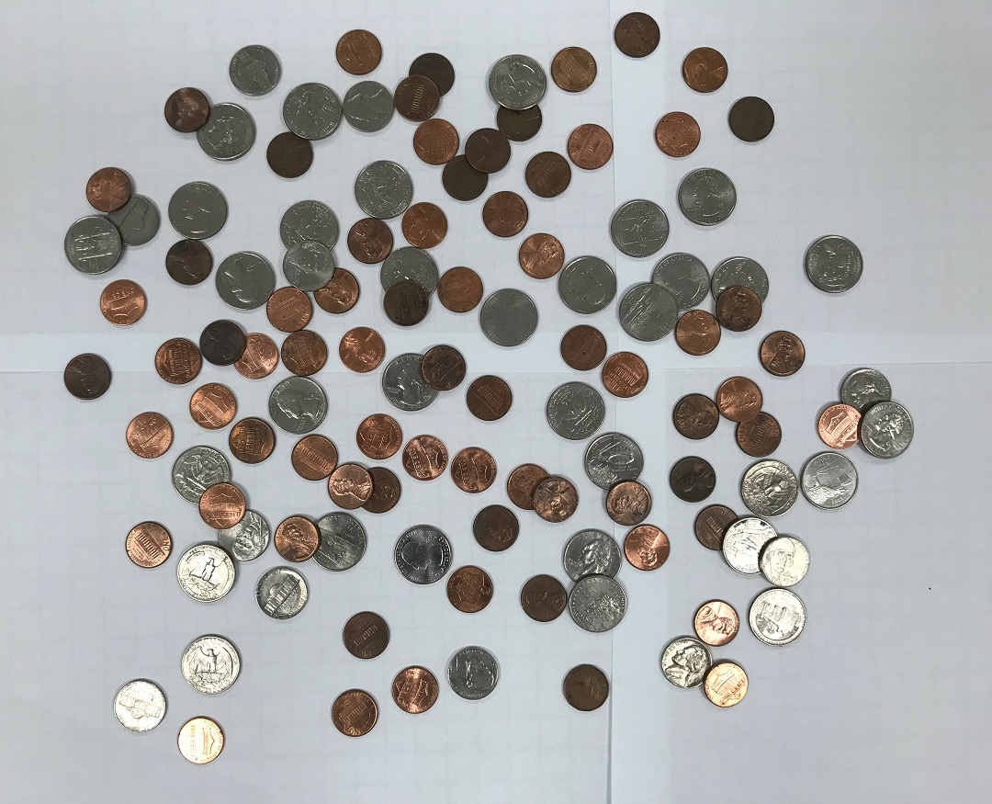
num pennies: 74 num quarters: 4 num nickels: 30 num dimes: 0 num half dollars: 0 total value: 324 cents

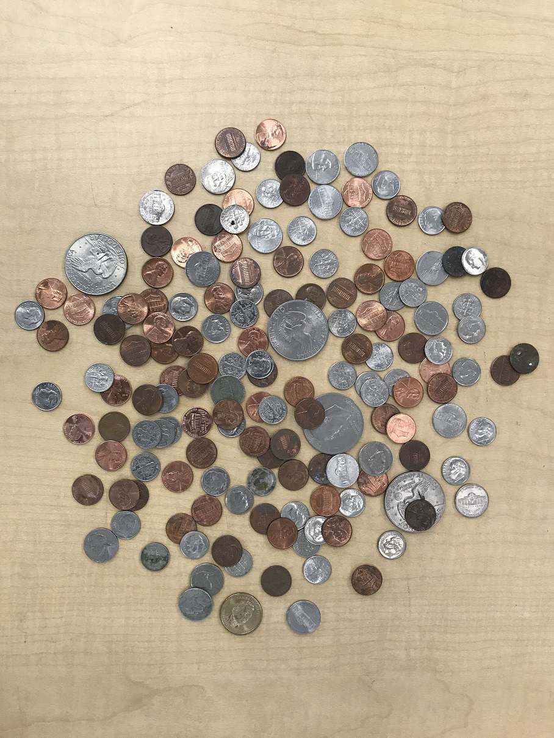
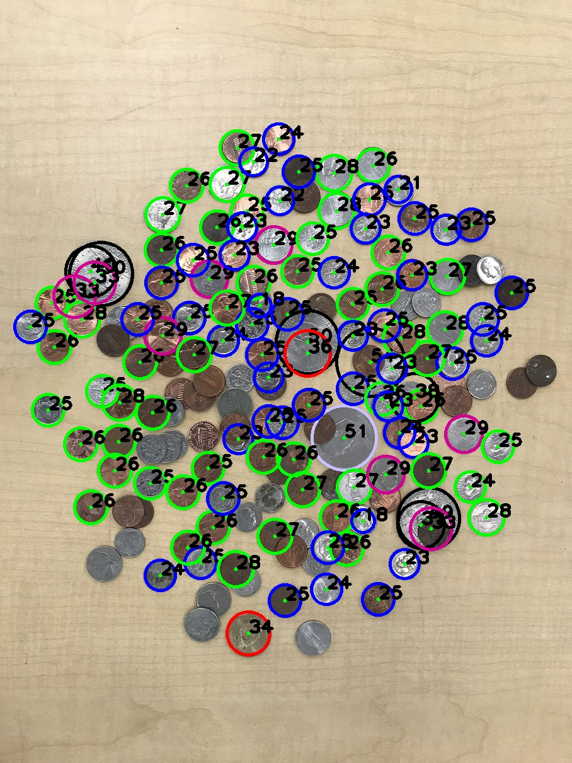

num pennies: 35 num quarters: 4 num nickels: 5
num dimes: 26 num half dollars: 1 total value: 470 cents

